**Machine Learning-Based Soil Fertility Analysis for Informed Decision-Making**  
*Analyse the soil fertility with the essential nutrients present in the soil*

Prakash Y Jagadeesh S Dr. P. Rama

[py3196@srmist.edu.in](mailto:py3196@srmist.edu.in) [js9441@srmist.edu.in](mailto:js9441@srmist.edu.in) ramap@srmist.edu.in

**Abstract:**

India, the world's second-most populous nation, has a deep connection to agriculture, engaging 60% of its population in farming. However, traditional farming practices pose significant challenges, such as reduced productivity and soil degradation. Addressing these longstanding issues involves embarking on a transformative mission to harness the potential of machine learning for revolutionizing Indian farming.

Machine learning, often perceived as complex, excels at processing specific data and uncovering insights for informed decisions. In the agricultural context, it becomes a potent tool for reshaping traditional practices. The primary focus lies in modernizing soil analysis, traditionally labour-intensive and time-consuming, leading to delayed decision-making—a luxury that farmers can ill afford. Leveraging machine learning aims to provide swift and precise solutions, offering real-time insights into soil fertility without relying on prolonged processes. This aligns seamlessly with the broader objective of bolstering food security and promoting sustainable agricultural practices. The impact of this technological transformation transcends the farm, nurturing both agriculture and the environment in a mutually beneficial relationship where both thrive.

Delving into the Soil Analyzer, the vision is clear: to empower India's farming community with knowledge and arm them with the tools for informed decisions. The goal is to guide agriculture toward a prosperous, sustainable, and environmentally responsible future. With technology as the catalyst, Indian farming is poised for a revolution that benefits not only the farmers but also the entire nation, ensuring a brighter future for India's agricultural landscape. This mission is driven by the urgent need to modernize agriculture in India and provide solutions that empower farmers and contribute to the nation's food security and environmental sustainability.

Keywords: Agricultural Decision Support; Predictive Modeling; User-Friendly Interface; Fertilizer Optimization; Soil Parameters; SFI (Soil Fertility Index); Random Forest; Machine Learning

**Introduction:**

At the forefront of a transformative wave sweeping through agriculture, the Soil Analyzer aims to harness the extraordinary capabilities of machine learning to predict soil fertility, introducing an innovative solution to amplify the efficiency and cost-effectiveness of farming practices. This endeavor relies on the analysis of a comprehensive and diverse dataset, including critical soil parameters such as pH levels, micronutrient concentrations, and soil texture nuances [2]. Through meticulous curation and processing of this dataset, a revolutionary scientific formula for calculating the Soil Fertility Index (SFI) has been engineered. This index provides farmers with a definitive, action-oriented measure of soil quality, graded on a scale from 1 to 10.

Central to the success of this pioneering effort is the dataset itself. Carefully curated and refined, it serves as the bedrock of the innovative approach. The dataset includes indispensable features intricately linked to soil fertility, from fundamental parameters like pH and electrical conductivity (EC) to more complex variables such as organic carbon (OC) and a spectrum of essential micronutrients—nitrogen (N), phosphorus (P), potassium (K), sulfur (S), calcium (Ca), magnesium (Mg), zinc (Zn), copper (Cu), iron (Fe), manganese (Mn), boron (B), molybdenum (Mo)—to soil texture (Tex). The integration of the groundbreaking SFI score into the dataset creates a clear and tangible target variable for model development, enabling precise predictions of soil fertility based on the provided input parameters. The primary goal is to empower farmers with a potent tool that enables the optimization of their agricultural practices [16]. With the ability to predict the SFI, farmers can make informed decisions about fertilizer application, saving invaluable time and resources. A lower SFI value signifies land areas with suboptimal fertility, while a higher SFI indicates the potential for bountiful cultivation. Equipped with this knowledge, farmers can accurately gauge the fertilizer required to enhance their soil's fertility. For instance, a farmer with an SFI of 7.5 can aspire to raise their land's fertility to the maximum score of 10, comprehending the amount of fertilizer needed to elevate the SFI by 2.5 points.

To enhance accessibility and usability, the development of a user-friendly interface will be incorporated. Farmers will have the capability to input pH values and micronutrient content directly into the interface, receiving instant SFI values. This feature not only simplifies the process but also empowers farmers to make data-driven decisions with ease. Beyond its immediate applications, this pioneering effort possesses the potential to guide farmers toward not only cost efficiency but also long-term sustainability. Moreover, it serves as a driving force for continuous research and experimentation, advancing the optimization of fertilizer usage for soil enhancement. The Soil Analyzer signifies a momentous stride toward a more prosperous, environmentally conscious, and productive future for agriculture, redefining the boundaries of what's achievable in farming and food security.

**Literature review:**

The available research, as evidenced by numerous research papers [2-16], illustrates a diverse landscape of approaches for assessing soil fertility and managing crops. These systems each have their unique merits and demerits, reflecting the evolving nature of agricultural technology. One of the primary merits of these solutions is their ability to provide cost-effective and reliable options for soil analysis. Many studies advocate the use of IoT-based technologies, allowing real-time monitoring of soil conditions. This innovation empowers farmers with continuous insights into their soil's health, facilitating immediate decision-making, particularly concerning the application of fertilizers and crop management [9, 12-16]. Furthermore, colorimetry and microcontroller-based analyzers are praised for their speed and portability, making them ideal tools for on-site soil nutrient detection, and offering swift and actionable results for farmers [13, 15].

However, these systems are not without their limitations. Traditional soil testing methods, which continue to be prevalent, often involve time-consuming and labor-intensive procedures, which can hinder the timely response needed in dynamic agricultural settings [2, 10]. Furthermore, relying on a limited set of parameters in these methods may lead to recommendations that do not fully capture the complex dynamics of soil fertility [10]. This can result in suboptimal agricultural practices. Traditional methods may also suffer from reduced accuracy due to factors such as soil heterogeneity, making localized recommendations less dependable [10]. IoT-based solutions, while providing real-time data, may still fall short in offering comprehensive predictive insights into soil health, potentially limiting their capacity for proactive decision-making [16].

In contrast to these approaches, the Soil Analyzer presents a promising alternative by leveraging advanced algorithms, including deep learning, convolutional neural networks, and machine learning techniques [2]. This approach offers a more holistic view of soil fertility, encompassing a broader range of parameters and historical data to deliver precise recommendations [2]. By merging technology with agricultural knowledge, this innovative system has the potential to revolutionize the farming landscape, enhancing the efficiency and productivity of crop management. With its focus on predictive modelling and the integration of diverse soil attributes, it stands out as a promising solution in the field of soil fertility analysis and crop prediction [2]. This depth and breadth of analysis, driven by cutting-edge technology, could be a game-changer in helping farmers make informed decisions, thereby elevating the agricultural sector to new heights. The available solutions indeed offer a multitude of valuable advantages that contribute to their relevance in soil analysis and agricultural management. One of their key merits lies in their preference for well-established and cost-effective methods for assessing soil properties, ensuring that farmers can access reliable data without a substantial financial burden, a critical factor in resource-constrained agricultural settings [12-16]. Moreover, recent research has underlined the prowess of IoT-based solutions, enabling continuous and real-time monitoring of soil conditions, which equips farmers with timely insights into the ever-changing state of their soil, supporting informed decisions regarding fertilizer application, crop management, and other vital farming activities [9, 12-16]. Furthermore, the availability of colorimetry and microcontroller-based analyzers is indeed a boon to the agricultural community, offering swift and portable tools that facilitate on-the-spot soil nutrient detection, providing immediate feedback to farmers for quick decision-making, which is often pivotal for effective agricultural practices [13, 15].

Nonetheless, these approaches are accompanied by a set of significant limitations that necessitate consideration [2, 10, 16]. Their reliance on conventional soil testing methods, for instance, is known to be labour-intensive and time-consuming, which can be particularly challenging in the context of fast-paced and dynamic agricultural operations [2, 10]. The traditional approach, often focusing on a limited set of parameters, may inadvertently lead to suboptimal recommendations for crop management, particularly when dealing with the intricacies of soil fertility, where a comprehensive view is crucial for well-informed decisions [10]. Furthermore, the accuracy of these methods can be significantly impacted by variables such as soil heterogeneity, rendering localized recommendations less reliable, thereby posing challenges in diverse agricultural settings [10]. Another drawback often observed in IoT-based solutions is their potential inability to provide in-depth predictive insights into soil health, somewhat limiting their capacity for proactive decision-making [16]. In contrast, the innovative Soil Analyzer you propose capitalizes on advanced algorithms, promising a more holistic view of soil fertility, considering a broader range of parameters, and incorporating historical data, addressing some of the limitations present in the current approaches [2].

**Proposed Methodology:**

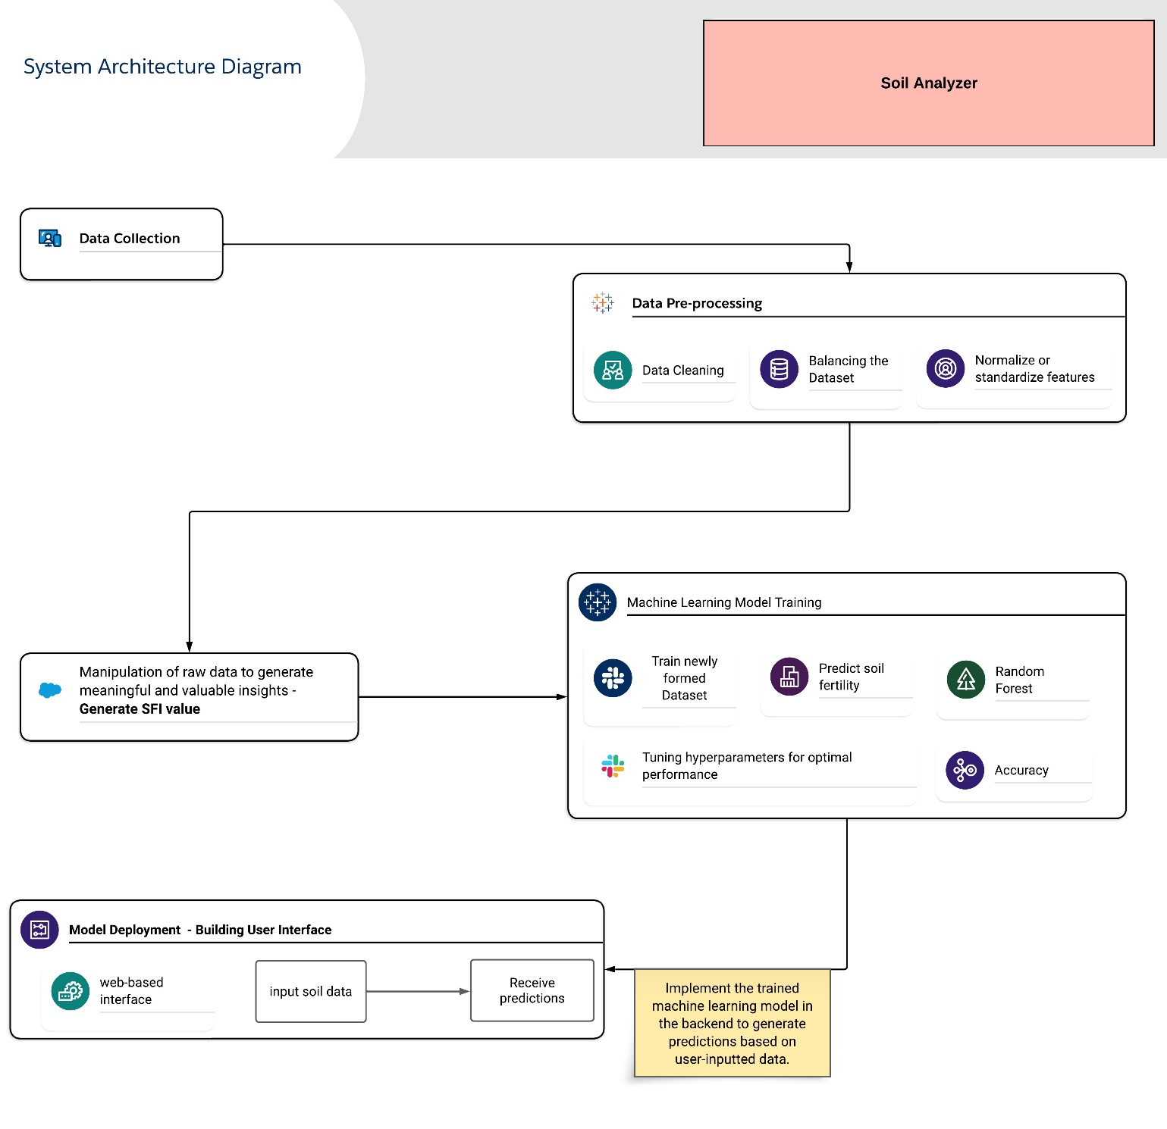

Methodologies employed in the innovative venture were designed to harness the potential of machine learning and data analysis, offering a dynamic solution to the persistent challenges faced by Indian farmers. Soil fertility, a cornerstone of successful agriculture, became the focal point of the study.

The systematic methodology of the Soil Analyzer is outlined, covering data collection, preparation, and the creation of a user-friendly interface. These procedures underpin the development of the innovative system. Below are the step-by-step methods performed in developing this.

1. **Data Collection:**

The data collection phase involves sourcing a comprehensive dataset prepared by the eminent G. B. Pant University of Agriculture and Technology. The dataset, comprising a total of 2738 instances, serves as an abundance of information, encapsulating vital soil attributes crucial for assessing soil fertility and overall quality. These attributes encompass parameters such as nutrient levels, including nitrogen (N), phosphorus (P), potassium (K), calcium (Ca), sulfur (S), magnesium (Mg), zinc (Zn), copper (Cu), iron (Fe), manganese (Mn), boron (B), and molybdenum (Mo). In addition to these micro and macronutrients, fundamental characteristics like pH, organic carbon (OC), electrical conductivity (EC), and a host of other pertinent soil properties are included in the dataset. Each data point within this dataset represents a piece of the puzzle that, when analyzed systematically, offers invaluable insights into the health and quality of the soil under examination.

1. **Data Pre-processing:**

The journey towards meaningful soil analysis begins with meticulous data pre-processing, where commitment to data integrity is paramount. The initial task involves addressing gaps or missing values within the dataset. To achieve this, zero values were identified and replaced with NaN in relevant columns. Subsequently, a careful approach was taken to fill in missing values by employing mean and median imputation in specific columns, considering the distribution of the data. This imputation process was executed separately for each feature, ensuring a comprehensive treatment of missing data. In parallel, potential outliers or anomalies within the dataset were identified and addressed using appropriate techniques to safeguard the integrity of soil analysis.

Furthermore, the data pre-processing journey includes the essential step of standardizing features. To achieve this, unnecessary columns ('id', 'label', 'SFI') were removed from the features (X), and the target variable (y) was separated. The StandardScaler from the scikit-learn library was then employed to standardize the feature values. This standardized approach ensures that various parameters in the dataset are on the same scale, preventing any single feature from dominating the machine-learning model's learning process due to a large numerical range.

The data collection and preparation phase of the Soil Analyzer are underpinned by a meticulous data cleaning process. The dataset, meticulously sourced from a reputable institution, undergoes careful cleaning and enrichment to ensure reliability and readiness for subsequent stages. This comprehensive approach lays a strong foundation for meaningful and precise soil analysis, with the prepared dataset serving as the canvas upon which a detailed picture of soil fertility and quality is painted. The implemented steps, including handling missing values and standardization, ensure that the dataset is well-prepared for machine learning modeling, with missing values addressed and features standardized for a consistent scale.

1. **Generating SFI Score:**

The Soil Fertility Index (SFI) stands as a fundamental component of the Soil Analyzer, serving as a comprehensive measure of soil fertility. It results from intricate calculations that provide insights into the health and vitality of the soil. The generation of SFI involves assessing various key attributes in the dataset, which together define soil health. This assessment encompasses factors such as nutrient levels, pH, electrical conductivity (EC), organic carbon (OC), and soil texture. Each of these aspects contributes to the SFI, reflecting its role in determining soil fertility. The SFI is not just a numerical value; it serves as a compass guiding agricultural decisions. Derived through interconnected scores, the SFI represents a holistic and precise evaluation of soil fertility. It brings together the multi-dimensional aspects of soil health into a single numerical rating, simplifying the understanding of soil quality for farmers and agricultural experts. It offers users actionable insights into areas that require improvement, be it nutrient enrichment, pH adjustment, salinity control, organic matter addition, or soil texture modification. Integrating these parameters into the SFI simplifies soil quality understanding for farmers and agricultural experts, facilitating informed decisions to enhance agricultural productivity and sustainability. The SFI is pivotal in the journey towards data-driven, environmentally responsible farming practices.

1. **Data Preparation and Splitting:**

The initial step involves gathering a comprehensive dataset, incorporating soil samples with known Soil Fertility Index (SFI) values and pertinent parameters, including pH, texture score, organic carbon (OC) score, electrical conductivity (EC) score, and nutrient score.

Following this, the dataset undergoes division into training and testing sets. The training set is employed to train the machine learning model, while the testing set is reserved exclusively for the evaluation of model performance.

1. **Machine Learning Model Training:**

In this phase, the selection of a machine learning model is based on its suitability for the Soil Fertility Index (SFI) prediction task. The Random Forest model is chosen for SFI prediction due to its effectiveness in handling complex datasets and providing feature importance scores.

The target variable, SFI, is defined along with the feature variables, encompassing pH, texture score, organic carbon (OC) score, electrical conductivity (EC) score, and nutrient score. The machine learning model is then trained on the training data to predict SFI based on these feature variables.

1. **Feature Importance Analysis:**

Following the training of the model, feature importance scores are generated. These scores are typically represented as numerical values ranging from 0 to 1. A score of 0 indicates that a feature has no impact on the model's predictions, while a score of 1 implies that a feature is of utmost importance.

1. **Feature Selection and Normalization:**

Following the generation of feature importance scores, a feature selection process is conducted to understand the relative importance of pH, texture, organic carbon (OC), electrical conductivity (EC), and nutrient scores in predicting Soil Fertility Index (SFI). Additionally, these scores are normalized, rescaling them to a consistent range, typically between 0 and 1. This normalization ensures that each feature contributes proportionally to the overall SFI calculation, thereby enhancing the accuracy and effectiveness of our Soil Analyzer.

1. **Weight Assignment:**

In accordance with the feature importance scores, weights are assigned to each parameter in the Soil Fertility Index (SFI) formula. Parameters with higher feature importance receive higher weights, reflecting their greater influence on soil fertility.

The SFI formula is defined as follows:

*SFI = (Weight_PH * pH + Weight_Texture * Texture_Score + Weight_OC * OC_Score + Weight_EC * EC_Score + Weight_Nutrient * Nutrient_Score) / (Weight_PH + Weight_Texture + Weight_OC + Weight_EC + Weight_Nutrient)*

**pH:** Represents the pH value of the soil.

**Texture_Score:** A score reflecting the soil's texture.

**OC_Score:** A score representing the organic carbon content.

**EC_Score:** A score reflecting the electrical conductivity of the soil.

**Nutrient_Score:** A score representing the overall nutrient content.

The assignment of scores for each feature is tailored to the specific requirements of soil attributes. For instance, considering the element nitrogen (N), if the nitrogen content in the soil falls within the range of 0 to 280 units, it is assigned a score of 1, signifying a lower nutrient level. Soil samples with nitrogen levels ranging from 281 to 560 units are assigned a score of 2, indicating a moderate nutrient content. On the other hand, soil samples with nitrogen levels exceeding 560 units receive a score of 3, denoting a higher nutrient content. Similar score assignment criteria are applied to other nutrient elements based on their respective optimal ranges for plant growth and soil health.

This approach ensures that the Nutrient_Score reflects the specific nutrient status of the soil, contributing to a comprehensive evaluation of its fertility. A similar custom score assignment is implemented for other attributes such as pH, soil texture, organic carbon content, and electrical conductivity, aligning the scores with the specific soil health requirements. This formula allows for the calculation of the SFI value for a specific soil sample based on the assigned weights and the feature values of the soil. By implementing this formula, users can obtain a precise numerical assessment of soil fertility.

**The formula for normalization:**

*normalized_scores = (scores - min(scores)) / (max(scores) - min(scores))*

This formula rescales the feature importance scores to a consistent range between 0 and 1.

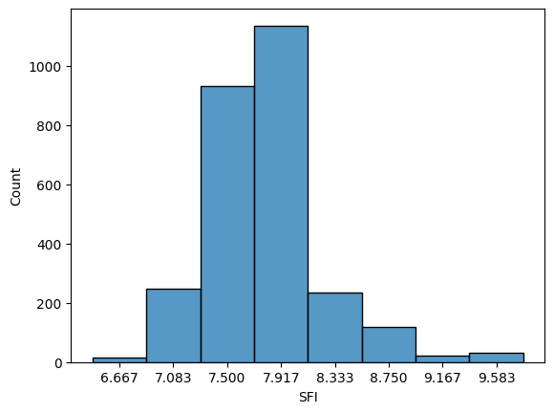

The distribution's breadth underscores the inherent variability in soil fertility, emphasizing the necessity for tailored agricultural strategies. Farmers can leverage this wealth of data to establish fertility targets, gauging the extent of improvement required for their specific land areas. Informed decisions are now readily accessible, enabling precision in fertilization and soil management practices. Additionally, the distribution may reveal outliers or anomalies, signaling potential data quality issues or unique soil conditions that warrant closer scrutiny.

1. **Machine Learning Model Training and Evaluation:**

Traditional methods of soil fertility assessment have often grappled with inefficiencies, inaccuracies, and the lack of real-time insights. Soil tests conducted in laboratories are typically time-consuming and can result in significant delays in decision-making for farmers. These tests may not always provide immediate data, limiting their utility in managing crop cultivation and nutrient application. In contrast, machine learning models excel at processing vast datasets swiftly and generating real-time predictions. By leveraging the capabilities of machine learning, the Soil Analyzer aims to overcome these limitations, providing a modern and efficient solution to soil fertility assessment.

The Soil Analyzer initiated a comprehensive evaluation of multiple regression algorithms to determine the most suitable approach for predicting soil fertility with precision. The unwavering commitment to accuracy prompted a systematic exploration of various algorithms, including Support Vector Machines (SVM), Decision Trees, and Random Forests.

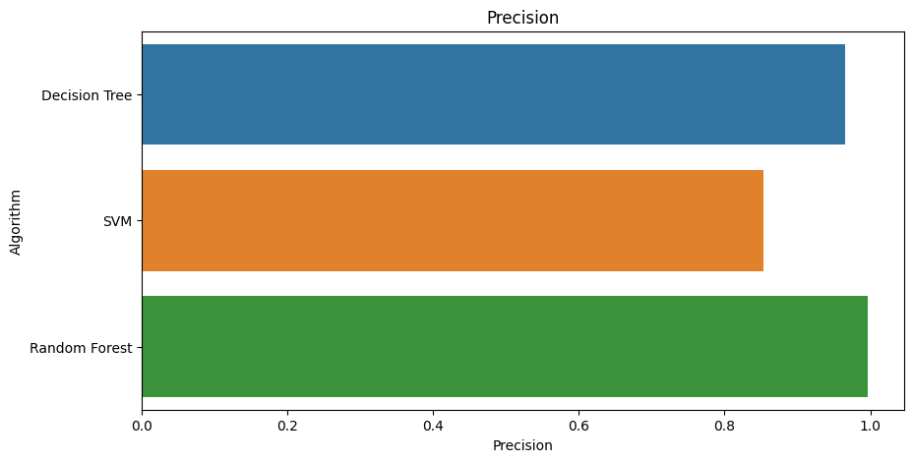

Among the evaluated algorithms, Random Forest stood out due to its exceptional accuracy and robustness in regression tasks. Random Forest is an ensemble learning method that combines the predictions of multiple decision trees. This ensemble approach not only enhances predictive accuracy but also mitigates the risk of overfitting, ensuring that the model generalizes well to unseen data. The selection of Random Forest as the final algorithm was based on its outstanding performance, particularly its ability to minimize errors. It exhibited a mean absolute error of only 0.03 degrees and an impressive accuracy score of 99.66%. The model's capability to generalize its understanding to new soil samples, its resistance to outliers, and the invaluable insights it provides into feature importance played pivotal roles in this decision. These results were a testament to the model's precision and reliability.

To predict soil fertility, the Random Forest machine learning model was implemented. This ensemble learning algorithm analyzes various soil parameters, such as pH, nutrient levels, soil texture, organic carbon, and electrical conductivity. During training, the model builds multiple decision trees, each focusing on a subset of features, fostering diversity and robustness. When provided with new soil data, the model leverages its learned patterns to predict the Soil Fertility Index (SFI), offering a numerical measure of soil quality. The Random Forest's strength lies in its ability to handle complex relationships, capture feature importance, and provide reliable predictions, making it a valuable tool for guiding agricultural decisions and promoting sustainable farming practices.

The evaluation process considered not only traditional metrics like accuracy but also precision, recall, F1 score, and mean absolute error, ensuring a comprehensive assessment of the model's performance in predicting soil fertility. With the predicted SFI score, farmers receive a clear assessment on a scale from 1 to 10, indicating the soil's fertility level—1 being the least fertile and 10 being the most fertile. This actionable index guides farmers in optimizing fertilizer application, minimizing costs, and promoting soil health, contributing to sustainable agriculture practices while preventing the overuse of fertilizers.

1. **Model Deployment and User Interface:**

The Soil Analyzer extends beyond soil fertility prediction by offering a comprehensive solution that prioritizes accessibility, user-friendliness, and actionable decision-making. During the Model Deployment phase, a user-friendly interface was meticulously crafted to ensure the easy accessibility and interpretation of the advanced technology, specifically catering to the farming community and agricultural experts. Accessibility is a cornerstone of the Soil Analyzer, emphasizing the need for highly accurate predictive models to provide easily accessible insights to those who need them the most—farmers. This accessibility encompasses both data input and interpretation, with a web-based interface designed for effective interaction with the Soil Analyzer system.

Crafted with a keen focus on user-friendliness, the interface facilitates seamless data input through an intuitive, step-by-step approach, reducing the likelihood of errors and maintaining data accuracy. Rigorous standards for data quality are upheld, incorporating validation protocols to ensure the reliability of predictions generated by the model. This user-friendly interface serves as a means to an end, enabling the generation of actionable insights by the trained Random Forest machine learning model in the backend. These predictions serve as a bridge between raw data and informed decisions, providing a comprehensive understanding of soil fertility encapsulated in the scientifically formulated Soil Fertility Index (SFI). Graded on a scale from 1 to 10, the SFI offers a clear and actionable evaluation of soil quality, with higher values indicating greater fertility and lower values signifying the need for intervention.

Additionally, in refining the soil fertility prediction model, strategic measures were implemented, including feature engineering, hyperparameter tuning, and rigorous model evaluation. The optimized model demonstrates heightened performance in real-world agricultural scenarios, and to ensure ongoing efficacy, a proactive data maintenance strategy was implemented. This strategy recognizes the dynamic nature of soil nutrient requirements influenced by evolving agricultural practices and incorporates regular infusion of updated soil nutrient data, aligning with the dynamic nature of agriculture and sustaining the model's accuracy as a valuable tool for informed decision-making about fertilizer application and sustainable soil management.

**Results and Analysis:**

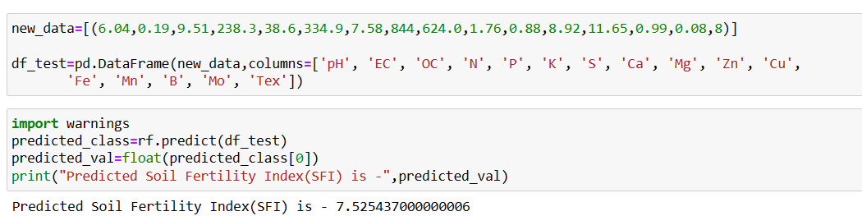

The image presents a compelling visualization of the predicted result generated by our innovative Soil Analyzer system when subjected to a new and previously unassessed set of soil data. To ensure the reliability and effectiveness of the Soil Analyzer, extensive testing and validation with new data were conducted. This critical phase aimed to assess the accuracy of predictions and the overall usability of the system. The process involved feeding the machine learning model with fresh, previously unseen data and evaluating its performance. For testing purposes, a sample dataset named "new_data" was created, containing essential soil parameters. This dataset, which included attributes like pH, electrical conductivity (EC), organic carbon (OC), and various nutrient levels (N, P, K, S, Ca, Mg, Zn, Cu, Fe, Mn, B, Mo), aimed to simulate real-world conditions where users input their soil data for analysis.

The new data was then used to predict the Soil Fertility Index (SFI) using the trained Random Forest machine learning model. The predicted SFI value for the new data was approximately 7.525, serving as an actionable assessment of soil quality. The accuracy of the predictions was a crucial aspect of the testing process. The low error margin of approximately 0.03 and a high accuracy score of approximately 99.66% demonstrated the model's precision in assessing soil fertility levels. These results provided a strong indication of the system's capability to make reliable predictions based on user-provided data.

The usability of the system was also assessed during this testing phase. The web-based user interface, designed with a focus on user-friendliness, ensured that farmers and agricultural experts could input their soil data accurately and with ease. The validation protocols integrated into the interface further enhanced data quality, promoting accurate predictions.

The predicted SFI value of 7.525 signifies the assessed soil's fertility level on a scale of 1 to 10. In this context, 7.525 falls within the range of moderately fertile soil.

**Conclusion:**

The "Machine Learning-Based Soil Fertility Analysis for Informed Decision-Making" research significantly contributes to reshaping agricultural practices through the integration of machine learning. This initiative, marked by thorough data collection, meticulous analysis, and predictive modeling, lays the groundwork for a more efficient, cost-effective, and sustainable approach to farming. Reflecting on the culmination of this journey, the profound impact of the Soil Analyzer research on the agricultural landscape becomes evident.

The primary objective of empowering farmers with a valuable tool for optimizing agricultural practices has been achieved through the prediction of the Soil Fertility Index (SFI). This enables farmers to make informed decisions about fertilizer application, ultimately saving time and reducing costs. The core philosophy of the research revolves around enhancing agricultural productivity, minimizing waste, and fostering sustainable practices. By providing farmers with a precise evaluation of soil quality through the SFI, the research facilitates strategic decision-making for improved crop yields and resource efficiency.

At the heart of the Soil Analyzer research lies its capacity to extract meaningful insights from an extensive dataset. Through the integration of various soil parameters, including pH, micronutrient levels, organic carbon, electrical conductivity, and soil texture, the research formulates the SFI. The machine learning model plays a pivotal role in translating this data into actionable predictions, bridging the gap between raw information and tangible outcomes. The development of a user-friendly interface further enhances accessibility, allowing farmers and agricultural experts to input soil data effortlessly and receive real-time predictions. Looking ahead, the data collected and the machine learning model can be extended and fine-tuned to adapt to evolving agricultural needs. Future research could explore optimizing fertilizer usage, experimenting with soil improvement techniques, and incorporating additional soil parameters and data sources into the analysis. The Soil Analyzer research stands as a technological revolution in agriculture, seamlessly integrating data-driven insights, predictive modeling, and user-friendly interfaces to usher in the era of smart agriculture. By empowering farmers to make informed, data-driven decisions, this research not only enhances productivity but also champions environmental sustainability.

Acknowledging the research's strengths, it is important to recognize certain limitations. The dynamic nature of soil micronutrient requirements necessitates further analysis by agricultural experts to determine precise fertilizer amounts. While the experimental scores generated by the model offer valuable initial assessments, the evolving nature of soil conditions underscores the significance of expert validation for accurate and context-specific recommendations. This limitation emphasizes the collaborative aspect of implementing machine learning models in agriculture, where domain expertise remains crucial for refining and contextualizing predictions.

**References:**

1. Kaggle Dataset prepared by G. B. Pant University of Agriculture and Technology.
2. Jamshed, Muhammad Ammar. “Analyze Soil Fertility Using Deep Learning Convolutional Neural Networks.” Shanlax International Journal of Arts, Science and Humanities, vol. 10, no. 3, 2023, pp. 1–5.
3. A Pandey, Shobhit & Kumar, Yogender & David, Arun. (2020). Research paper soil.
4. Prabhu, Shubham & Revandekar, Prem & Shirdhankar, Swami & Paygude, Sandip. (2020). Soil Analysis and Crop Prediction. International Journal of Scientific Research in Science and Technology. 117-123. 10.32628/IJSRST207433.
5. Bhavya Agarwal, Shubham Pokhriyal, Satvik Vats, Vikrant Sharma, Priyanshu Rawat, Madhvan Bajaj, "Crop Prediction Using Ensemble Learning", 2023 5th International Conference on Inventive Research in Computing Applications (ICIRCA), pp.90-95, 2023.
6. Jhansi Swetha, G. Kalyani, B. Kirananjali, "Advanced Soil Fertility Analysis and Crop Recommendation using Machine Learning", 2023 7th International Conference on Trends in Electronics and Informatics (ICOEI), pp.1035-1039, 2023.
7. Josephine Selle Jeyanathan, B. Medha, G. Tharun Venkata Sai, R. Bharath Kumar, Varsha Sahu, "Automated Crop Recommender System using Pattern Classifiers", 2023 International Conference on Intelligent Data Communication Technologies and Internet of Things (IDCIoT), pp.567-572, 2023.
8. Aditya Motwani, Param Patil, Vatsa Nagaria, Shobhit Verma and Sunil Ghane, "Soil Analysis and Crop Recommendation using Machine Learning", IEEE Conference, 2022.
9. Haedong Lee, Aekyung Moon, Gajeong- ro and Yuseong-gu, "Development of Yield Prediction System Based on Real-time Agricultural meteorological Information", ETRI 218 Gajeong-ro Yuseong-gu, pp. 305-700.
10. N, Raghu & K N, Manjunatha & B, Kiran & Chetia, Mr & Engineering, Electronics. (2020). COLLABORATIVE RESEARCH IN APPLIED SCIENCE AND ENGINEERING (CRASE) DESIGN AND DEVELOPMENT OF SMART SOIL ANALYSER. 1. 24.
11. Mot, Andrei & Ion, Violeta & Badulescu, Liliana & Roxana Maria, Madjar & Ciceoi, Roxana. (2022). SOIL QUALITY ASSESSMENT BASED ON THE C: N RATIO IN AN ALLUVIAL SOIL TREATED WITH MICROBIAL INOCULANTS.
12. Natarajan, Thangadurai & Sb, Vinay & Chikkalingaiah, Prasanna. (2019). Fertilizer Optimization by a Smart Soil Analyzer with a Soil Tester for Agriculture Applications. International Journal of Advanced Trends in Computer Science and Engineering. 8. 3628-3631. 10.30534/ijatcse/2019/146862019.
13. Pallevada, Hema & Velagapudi, Engineering & Siddhartha, Ramakrishna & Chandhra, Bharath & Gadde, Sai & Venkata, Teja & Munnangi, Kumar & Chinta, Mukesh. (2021). Real-time Soil Nutrient Detection and Analysis. 10.1109/ICACITE51222.2021.9404549.
14. Lin, J., Wang, M., Zhang, M., Zhang, Y., Chen, L. (2008). Electrochemical Sensors for Soil Nutrient Detection: Opportunity and Challenge. In: Li, D. (eds) Computer And Computing Technologies In Agriculture, Volume II. CCTA 2007. The International Federation for Information Processing, vol 259. Springer, Boston, MA.
15. Regalado, R G and Jennifer C. dela Cruz. “Soil pH and nutrient (Nitrogen, Phosphorus, and Potassium) analyzer using colorimetry.” 2016 IEEE Region 10 Conference (TENCON) (2016): 2387-2391.
16. Pyingkodi, M. et al. “IoT-based Soil Nutrients Analysis and Monitoring System for Smart Agriculture.” 2022 3rd International Conference on Electronics and Sustainable Communication Systems (ICESC) (2022): 489-494.